

**The Financial Cycle and the UK Economy**

Speech given by

Sir John Gieve, Deputy Governor, Bank of England

London Stock Exchange 18 July 2008

1

All speeches are available online at [www.bankofengland.co.uk/publications/Pages/speeches/default.aspx](http://www.bankofengland.co.uk/publications/Pages/speeches/default.aspx)

# Introduction

These are troubled times for both the City and the economy more widely. After 15 years of unbroken growth and low inflation, the prospect for the rest of this year is uncomfortable: inflation will continue to rise sharply while growth tails off and unemployment picks up. And the downturn is particularly pronounced in the banking sector. While the acute concerns about funding that emerged last summer have ebbed a little since March, worries about future losses, profitability, and even the viability of some business models, have been growing on both sides of the Atlantic, leading to sharp falls in most equity prices and, in the UK, to difficulties in bank rights issues.

This morning I want to say a little about the challenges this sets the MPC in the short term but also to address some of the longer term lessons of the credit crunch.

# Global imbalances and the credit crunch

One of the striking aspects of this downturn is that it started – at least in Europe - in the financial sector. The level of defaults on lending to households and companies is still very low. The credit squeeze here has not been, initially at least, a response to losses at home but driven by the dramatic loss of liquidity in financial markets (Chart

1) which was set off by the US sub-prime downturn.

One puzzle has been why that problem in one part of one country’s housing market has triggered such global turmoil. Of course the US is not just any country. But while the numbers may look large in absolute terms, even if sub-prime losses reach $500 billion as the IMF have suggested1, they will be quite modest relative to the size of the whole banking system.

The answer is that sub-prime provided only the initial spark and the fire fed on much broader weaknesses in the financial sector, which in turn had been allowed to develop by imbalances in the global economy.

The most striking feature of the world economy in the last decade has been the explosive growth of China and other emerging economies. For example, since China joined the WTO in 2001, it’s imports and exports have expanded on average by 25% each year, more than twice the growth in world trade over that period.

1 <http://www.imf.org/External/Pubs/FT/GFSR/2008/01/index.htm>

But these countries have been reluctant to rely, in net terms at least, on foreign capital either because of their own previous currency crises or their observation of the painful adjustment experienced by others. Foreign direct investment has been permitted to allow the transfer of technology and expertise but these capital flows have been re- exported through accumulation of foreign reserves. Some countries have preferred to maximise their production of tradeables by undervaluing their real exchange rates through fixed or heavily-managed nominal exchange rates to the US dollar. As the absolute sizes of their economies have increased, so have their current account surpluses and the scale of their foreign reserve accumulation is now massive. Global foreign exchange reserves have increased from just under $2 trillion in early 2000 to over $7 trillion in May 2008 and are forecast to grow by $1 trillion in 2008 alone (Chart 2).

The vast excess savings of these economies needed somewhere to go. The gainers were in the West where the asset and financial markets were most developed. The inflow brought greater liquidity to markets and helped to create the conditions for widespread underpricing of risk. The counterpart to the excess savings in the East became expansion of credit, the growth of consumption and a boom in asset prices in the West. Looked at in a global perspective, the dramatic increases in wealth and living standards in emerging economies have been a great step forward. But the growth pattern has been unbalanced and we are now having to handle the inevitable correction.

In that sense, the innovation that led to the exponential growth of new structured credit markets in recent years was not just a product of new technology and more aggressive risk taking in Western financial markets; it was also a flawed response to these wider imbalances in the global economy.

# Sources of procyclicality

But weaknesses in modern credit markets, and the ‘originate to distribute’ model of banking, have certainly been a good part of the problem. The development of new markets and credit instruments has tended to amplify the financial cycle – they have been pro-cyclical in the jargon – and has introduced or strengthened the misalignment of incentives and flawed measures of risk.

Of course financial markets have always tended to develop a strong cycle. There is a natural feedback between asset prices and credit availability. When credit supply

increases, households and companies who were previously credit constrained find it easier to borrow. Their increased ability to buy assets bids up prices. And these higher-priced assets can be used as collateral to secure loans. So as asset prices rise, so does collateral, thereby increasing the willingness of banks to supply credit.

But in recent years this has been reinforced by some structural and regulatory changes. The growth of credit risk transfer through securitisation has tended to increase the proportion of banks’ balance sheets that come under mark-to-market accounting. Even gradual changes in the values of the underlying loans have tended to appear as abrupt changes in banks’ trading and treasury books. When liquidity was abundant, asset values were high and marked-to-market profits were high. Now that liquidity is scarce and asset values lower, mark-to-market losses and write-downs are high.

The widespread use of credit ratings in valuing assets and managing counterparty credit risk has also had an impact. Credit rating agencies try to rate through the cycle. And for corporate ratings they may well succeed. But for some structured finance products, such as re-securitisations of sub-prime backed securities they (like many others) misjudged the impact of a downturn in the cycle and the non linearity of returns. As a result, there have been wholesale downgrades of the credit ratings of structured securities over the past 12 months. The problem for the financial system is that these ratings are often hard-wired into decision making. Certain classes of investors are forced to sell assets when they lose a AAA or investment grade rating.

Remuneration structures have also amplified risk taking in the upswing. Two features of remuneration in the financial industry are that they are asymmetric (there is unlimited upside for high performance but a floor on the downside) and tend to be based on short-term targets. The asymmetry in reward creates an incentive to gamble and short-term performance targets encourage traders to follow rather than counter a deviation from long-run fundamentals. Even where the incentives were paid in options linked to the medium-term performance of the employer, the apparent rewards have been highly cyclical.

In addition, regulation can also encourage procyclical risk taking. Basel I, for example, encouraged the growth of securitisation and the ‘originate to distribute’ model of banking because holding the low risk elements of a loan portfolio in the banking book were relatively heavily capital-weighted. Basel II contains more carefully calibrated capital risk-weights and is a considerable improvement over Basel

1. But the risk measures are drawn from the market and share some procyclical features. Weights increase as credit risk rises so risk-weighted assets will seem relatively low during tranquil economic times and relatively high during periods of stress. While there may be scope within Pillar II to address this, it is too early to know whether that can be used effectively.

The combination of these market and regulatory effects have amplified risk taking during the boom and is now constraining risk appetite as financial conditions have deteriorated.

# Policy responses

Since the crisis broke last summer, regulators, governments and central banks have come together in the Financial Stability Forum (FSF) to analyse what has gone wrong and agree an international response. Its recommendations have been approved by the IMF and the G8 and include a range of measures to fill particular gaps or put right particular faults in the regulatory system by:

* + ***strengthening prudential oversight of capital, liquidity and risk management;*** implementing Basle II and requiring more capital against, for example, off-balance-sheet vehicles, securitisations and tail risk;
  + ***enhancing transparency and valuation*** particularly for complex structured financial products and off-balance sheet vehicles;
  + ***changing the role and uses of rating agencies,*** including by distinguishing ratings of corporates and structured products***;***
  + ***strengthening the authorities’ responsiveness to risk;*** and
  + ***increasing the robustness of arrangements for dealing with financial stress;*** ensuring central banks’ operational frameworks are flexible enough to deal with extraordinary situations in money markets and mechanisms for dealing with weak or failing banks are put in place.

More generally we are discussing in the FSF how the authorities can go further in moderating the financial cycle.

Of course monetary policy can play a role in this. One goal of monetary policy is to stabilise the economy in the face of shocks and central banks have always looked at credit and money growth as important indicators of the state of the economy. The rapid growth of credit in 2006 for example was one factor leading the MPC to start raising interest rates. However central banks have been wary of putting a lot of weight on disciplining financial markets by changing interest rates. Famously Alan Greenspan asked “But how do we know when irrational exuberance has unduly escalated asset values, which then become subject to unexpected and prolonged contractions..?”

There are two good reasons for care. First policy has to be appropriate for the whole economy; the interest rates which would be needed to have a significant effect, say, on the growth of house prices in recent years might have been far too high for other industries. Secondly central bankers have been cautious to put much weight on their own assessments of when an increase in asset prices is becoming unsustainable. If they get the judgement wrong, they risk slowing growth needlessly and bring inflation persistently below target.

Even if central bankers put more weight in future on their judgements of excesses in financial markets, it seems highly desirable also to make the regulatory system more counter-cyclical. A number of proposals have recently been put forward, which would have the effect of directly increasing a bank's capital requirements during an economic upturn and allow room for capital requirements to fall in a downturn. For instance Professors Goodhart and Persaud have put forward a scheme linking a bank's capital to the growth in its assets. Another possibility is to learn from the Spanish system of requiring banks to set aside general provisions against their loan book in good times which can be a cushion against losses in the downturn. There are some drawbacks to each of these particular proposals but we are discussing the best approach both with the FSA and with our international colleagues in the FSF.

# Current challenges for the MPC

Making sure we do set in place capital and liquidity regimes which dampen the next cyclical upswing in financial markets is important. More immediately, we also have to deal with the present conjuncture and I want to finish this talk with some reflections on that.

If the sharp credit squeeze was the only challenge we faced, the Monetary Policy Committee would be expected to continue reducing rates to mitigate the risks of an excessive fall in demand and in inflation in the medium term. But of course we do face another simultaneous shock, the sharp rise in commodity prices, which is driving up inflation across the world. And that raises the question whether we should be raising rates rather than reducing them. Moreover recently each month seems to have brought more worrying news on both fronts.

*The cost shock*

In the May *Inflation Report*, the Committee forecast a pickup in inflation to well over 3 per cent, above target and driven in large part by the huge rises we have seen in energy and food prices (Chart 3). Since those projections were put together, oil prices have risen a further 20% and food prices by a further 5%. And the Consumer Price Index has risen faster than we were expecting, reaching 3.8% in June. We are a little behind the US where inflation now stands at 5% or the Euro area where it has reached 4% but the gap is expected to continue to narrow. The peak monthly rate will depend on the exact timing of energy price rises but we are expecting inflation to be well over 4% for much of the rest of the year.

Of course, not all prices are rising so quickly. The prices of clothing and footwear fell by almost 8% over the past year. And the price of durable goods like plasma TVs has been falling even faster. But it is the rising cost of regularly purchased essential goods, like food and petrol, which attract most attention and probably drive people’s inflation expectations, which have continued to drift up.

This increase reflects in large measure a rise in world prices for commodities which we cannot avoid, but we must ensure that it is only a temporary spike and that inflation returns to target when this year’s increases fall out of the index in a year’s time. Above all that means ensuring that the higher rate of inflation does not become embedded in the expectations and behaviour of wage and price setters. The fact is that when their relative prices rise we cannot avoid a transfer to the producers of oil

and other commodities, because they are difficult to substitute out of. That transfer is bound to hit real wages one way or another but the more that is resisted and nominal wages are pushed up, the greater the cost is likely to be in unemployment and slower growth.

We have no direct lever on public expectations. We need not just to assert our determination to bring inflation back to target but ensure that our words are credible. So, in setting interest rates we need not just to assess the balance between supply and demand pressures in the economy which will set the context for price and wage decisions in the medium term, but also ensure that our decisions are understood and seen to respond to the economic developments in inflation and output that people are experiencing.

It is clear that with inflation rising well above target we need a period of slower growth to create a margin of spare capacity. The questions we discuss and reconsider each month are how big a margin is necessary and what level of interest rates is needed to bring it about.

*The Credit Crunch*

On the scale of the necessary output gap, for example, we need to take account of the supply effects of the doubling of oil prices and the impact of migration. On the other side we need to judge how sharp a slowdown is already in train.

In deciding the necessary level of interest rates we need not just to focus on the level of Bank Rate. We need also to take account of the impact of the turmoil in the banking sector which is now leading to a fierce squeeze on credit especially in the housing market but not just there. The increase in bank margins over safe rates have offset the cuts we have made to Bank Rate since last summer and the tightening of other conditions have introduced some quantity restrictions which are not fully captured in price. Our credit conditions survey suggests that this squeeze may intensify in the coming months.

Timely sources of data suggest that the economy is already slowing fast. The CIPS survey balances are now pointing to a contraction in activity in manufacturing, construction and services (Chart 4). House prices and transaction numbers are falling rapidly with direct effects on house builders and related services. And while there are winners as well as losers from lower house prices, there are signs that the housing market is affecting consumer confidence. More broadly, there are signs that the

tightening of credit conditions is beginning to affect both consumption and investment. Most importantly, the sharp increases in commodity prices are squeezing real take-home pay which is bound to impact on consumption at some point.

# Conclusion

I began this speech by highlighting how the recent events in financial markets have been facilitated by the integration of emerging economies into the global economy. Of course, I could make an even closer link with rising commodity prices. The rapid expansion in activity in these economies has inevitably put pressure on the global price of energy and other raw materials, whose supply is relatively fixed at least in the short run. That is showing up in rising inflation world wide (Chart 5).

So is it right to conclude, as some have, that the path of inflation is determined abroad? Certainly commodity prices have an effect in the short run. But it is domestic monetary policy – the decisions that the Monetary Policy Committee take each month, together with the overarching framework that defines our target – that determines the path UK inflation in the medium-run. The MPC will continue to assess the balance between the risks of higher inflation from the commodity cost shock and the downside risks to output (and to inflation in the medium term) from the credit crunch. But I can assure you that we will do whatever it takes to bring inflation back to target in the medium term.

# Chart 1: Financial Market Liquidity Chart 2: EME holdings of FX reserves

Liquidity index

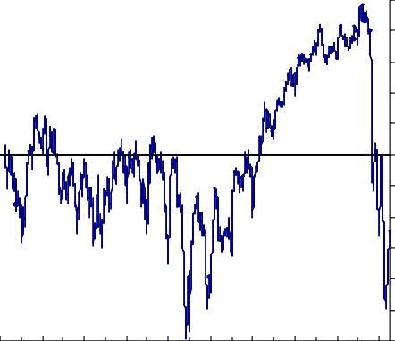1.0

0.8

0.6

0.4

0.2

+ 0.0-

0.2

0.4

0.6

0.8

1.0

1.2

90 92 94 96 98 00 02 04 06 08

Per cent 40

35

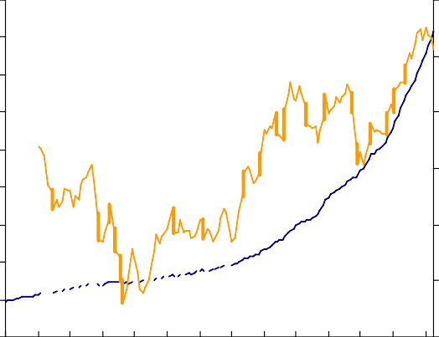

US$ (RHS)

Annual percentage change (LHS)

30

25

20

15

10

5

0

-5

1995

1996

1997

1998

1999

2000

2001

2002

2003

2004

2005

2006

2007

2008

US$tr

6

5

4

3

2

1

0

# Chart 3: Brent Oil Prices Chart 4: Survey-based measures of activity

Construction

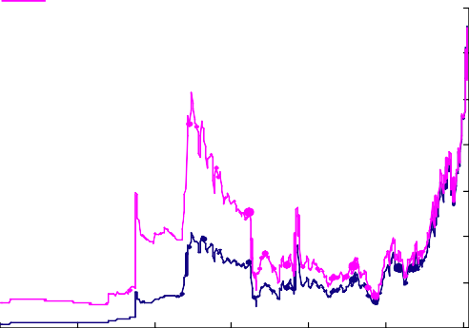

Nominal

Real

US dollars (2008) pe



r barrel Services

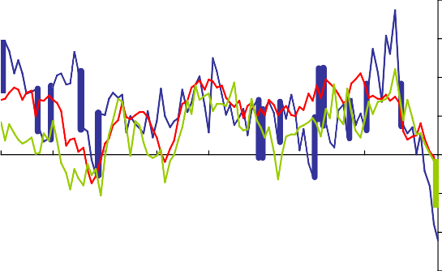

Index: 50 = no change

70

140

120

100

80

60

40

20

0

1960 1968 1976 1984 1992 2000 2008

Manufacturing

2000 2001 2002 2003 2004 2005 2006 2007

65

60

55

50

45

40

35

2008

# Chart 5: Global inflation

nt 9

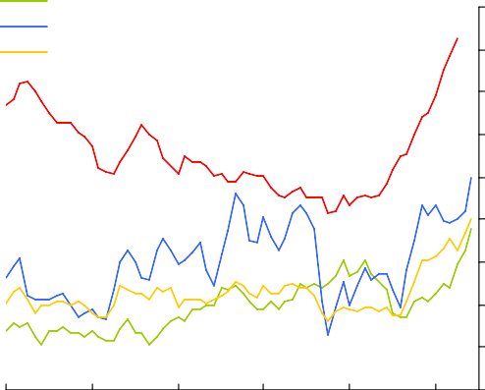

EMEs UK US

Euro Area

Per ce

8

7

6

5

4

3

2

1

0

2003 2004 2005 2006 2007 2008

Source: CIPS